**How to run the web user interface:**

Use command prompt inside the file and do this:

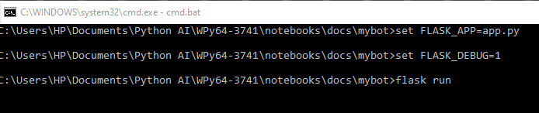

And upon flask run the web

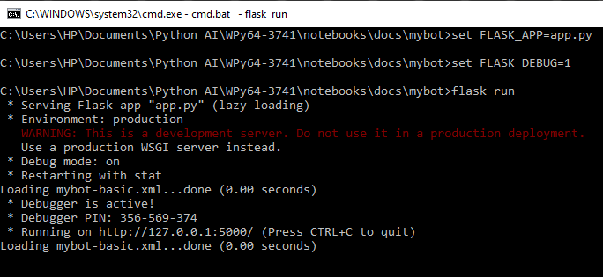

Or you can just do this:

